# **Validation Report Cost-Obj**

## *Summary Report*

*OBJECT*

IfcRoof.NOTDEFINED

GlobalId: 2cr5a8oczF5PorVi$sZ3$9

Obj Name: Tetto di base:Latero Cementizio - 27 cm:170917

*COST ITEM*

IfcCostItem

Price List Code: OC.EEA.a04.E0200.L0011.0100.-

GlobalId: 3PAaum4cz0J969LT9v2Jyp

Cost Name: Brick floor thickness 27cm

*CHART*

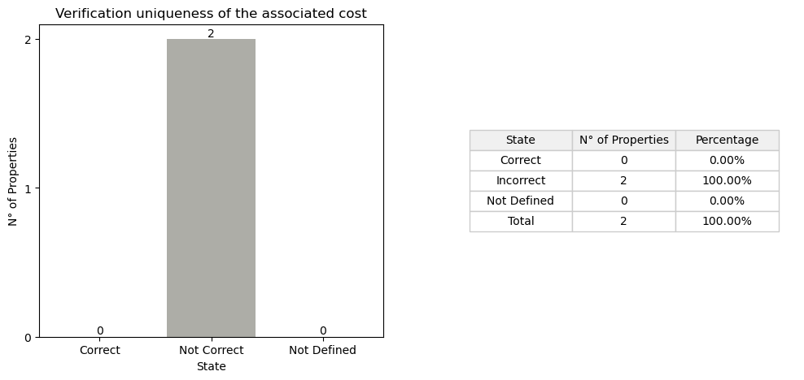

## *Detail Table*

|  |  |  |
| --- | --- | --- |
| **State** | **N° of Properties** | **Properties** |
| Correct | 0 |  |
| Incorrect | 2 | Entity TypeEnum |
| Not Defined in the obj | 0 |  |
| Not Defined in the cost | 1 | IsExternal |
| Not Defined in the cost and obj | 8 | ThermalTrasmittance AcousticRating FireRating LoadBearing Compartimentation Status PitchAngle Width |

## *Detail Report*

**🔸Number of Correct Properties: 0**

**🔸Number of Incorrect Properties: 2**

Entity: ✗   
 • #20=IfcSlab('0R4MeUizL4xx88L1z7e_Vh',$,'Sample element of brick floor','Sample element of brick floor',$,$,$,$,.FLOOR.)   
 • #4125=IfcRoof('2cr5a8oczF5PorVi$sZ3$9',#21,'Tetto di base:Latero Cementizio - 27 cm:170917',$,'Tetto di base:Latero Cementizio - 27 cm',#4099,#4124,'170917',.NOTDEFINED.)   
  
TypeEnum: ✗   
 • #20=IfcSlab('0R4MeUizL4xx88L1z7e_Vh',$,'Sample element of brick floor','Sample element of brick floor',$,$,$,$,.FLOOR.)   
 • #4125=IfcRoof('2cr5a8oczF5PorVi$sZ3$9',#21,'Tetto di base:Latero Cementizio - 27 cm:170917',$,'Tetto di base:Latero Cementizio - 27 cm',#4099,#4124,'170917',.NOTDEFINED.)

**🔸Number of Not Defined Properties in Obj: 0**

**🔸Number of Not Defined Properties in Cost Item: 1**

IsExternal: ✗   
 • property not found in COST ITEM

**🔸Number of Not Defined Properties in Cost Item and Obj: 8**

ThermalTrasmittance: ✗   
 • property not found in OBJ and COST ITEM  
  
AcousticRating: ✗   
 • property not found in OBJ and COST ITEM  
  
FireRating: ✗   
 • property not found in OBJ and COST ITEM  
  
LoadBearing: ✗   
 • property not found in OBJ and COST ITEM  
  
Compartimentation: ✗   
 • property not found in OBJ and COST ITEM  
  
Status: ✗   
 • property not found in OBJ and COST ITEM  
  
PitchAngle: ✗   
 • property not found in OBJ and COST ITEM  
  
Width: ✗   
 • property not found in OBJ and COST ITEM